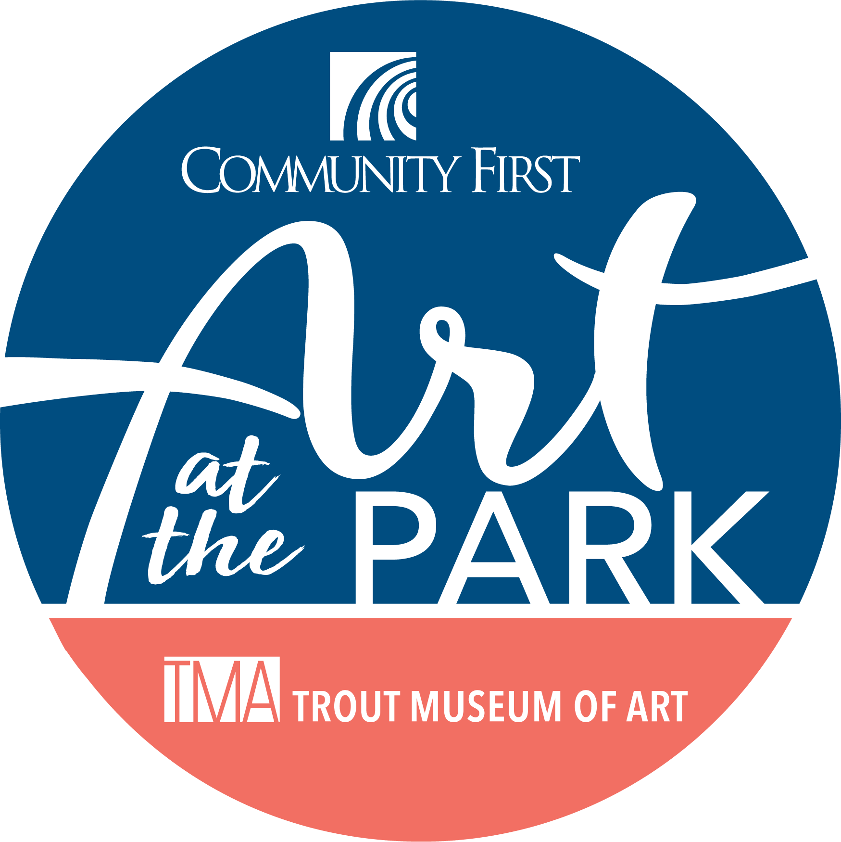Volunteer Waiver

Art at the Park 2024  
Presented by Community First Credit Union

**Volunteer Contact Information:**

Volunteer Name (first and last): _____________________________________ Date of Birth: _________

### Address: ___________________________________________________________________________

City: ______________________________________ State: ___________ ZIP: _________________

Phone: (_______)________________ E-mail: _____________________________________________

Emergency Contact Name: ­­­­­­­­­­­­­­­­­­_______________________________ EC Phone: (_____)_______________

**Photo Release:**  
Volunteers grant the Trout Museum of Art, Art at the Park, and their representatives, the unrestricted right to use and publish photographs of them, or in which they may be included, for editorial trade, advertising, and any other purpose and in any manner and medium; and to alter the same without restriction. I hereby release the Trout Museum of Art, Art at the Park, and their representatives from all claims and liability relating to said photographs.

**Waiver of Liability:**

Waiver of Liability is for all activities involved with this event**.** Volunteers are voluntarily participating in this event and release from all liability and promise not to sue the Trout Museum of Art, the Fox Cities Building for the Arts, their employees, directors and volunteers from any and all claims resulting in any physical or psychological injury, illness, damages, or economic or emotional loss suffered because of participation in this event, including travel to, from, and during the event. **If the volunteer is under the age of 18 their legal guardian is required to consent to these terms for the volunteer.**

**Volunteer Signature**

**Or Parent/Guardian Signature** ___________________________________ Date _________________

Email completed waivers to fgilboa@troutmuseumart.org, return to the Trout Museum of Art front desk,

or bring the day of the event.

**When you arrive for your shift, sign-in at the TMA Tent on Franklin St.**